

JOB PORTAL

SOFTWARE REQUIREMENT SPECIFICATION

Project for .Net Core Training Boot Camp

Aitrich academy
Radhi Krishna

Table of Contents

Introduction 1
Purpose 3
Scope 4
Objective 5
Functional Requirements 7
Primary actors of the system 8
Use Case Diagram 9
User Stories 12
Business Process Diagram 16
Non-Functional Requirements 17
Technical Requirements 18
Conclusion 19

Introduction

Overview of the Job Portal System and its purpose

A job portal system is a digital platform designed to connect job seekers and employers efficiently. It serves as a centralized hub where employers can post job openings, and job seekers can explore and apply for suitable positions. The system typically includes features such as profile creation, job search filters, resume uploads, job alerts, and application tracking. For employers, it offers tools to manage job postings, filter applicants, and communicate with potential hires. For job seekers, it provides a seamless way to access a wide range of opportunities and tailor their applications to match specific requirements. The purpose of a job portal system is to simplify and streamline the recruitment process, reducing the time and effort for both parties while increasing the likelihood of successful matches

Clearly defining system requirements is a critical step in ensuring the successful development and implementation of a job portal system. Requirements act as the foundation upon which the entire system is built. They outline the functional and non-functional expectations of the platform, providing developers with a clear roadmap to follow. When requirements are well-defined, it minimizes ambiguities, reduces the risk of scope creep, and ensures that the end product aligns with the needs of stakeholders. Furthermore, precise requirements help identify potential challenges early in the process, allowing for proactive problem-solving and resource allocation. A comprehensive understanding of system requirements also facilitates effective communication among project teams, stakeholders, and end users, fostering collaboration and ensuring the delivery of a user-friendly, efficient, and reliable job portal system

Purpose
The purpose of the Software Requirements Specification (SRS) document for the job portal system is to provide a comprehensive and structured description of the system's objectives, features, and design constraints. This document acts as a reference point for all stakeholders, including developers, testers, project managers, and clients, to ensure a clear understanding of the system's purpose and functionality. By defining the system requirements in detail, the SRS helps align the development process with user needs and business goals, serving as a roadmap for successful implementation.
The primary focus of the SRS document is to capture and document both the functional and non-functional requirements of the job portal system. Functional requirements detail the specific features and capabilities of the system, such as job search functionality, user registration, job application management, and administrative tools. Non-functional requirements address the performance, scalability, security, and usability aspects that define how the system should operate under various conditions. By thoroughly documenting these requirements, the SRS ensures that the development team has a clear and precise understanding of what needs to be built, reducing the risk of misunderstandings, delays, and deviations from the project’s objectives.

Scope

Scope of the Job Portal System
The job portal system aims to serve as an online platform that bridges the gap between job seekers and employers by facilitating job postings, applications, and recruitment management. The scope includes creating a user-friendly interface for both job seekers and employers, providing efficient search capabilities, and streamlining communication between the two parties. The system will support various industries and job types, catering to diverse employment needs. It will also incorporate tools for administrative oversight, ensuring that the platform remains secure, functional, and compliant with relevant regulations. By addressing the recruitment needs of small to large organizations and individual job seekers, the system will act as a comprehensive recruitment solution.

Main Functionalities and Features
The job portal system will include several core features to meet the needs of its users. For job seekers, functionalities will include account creation, resume uploads, advanced job search filters, job recommendations, and application tracking. Employers will have access to features such as job posting management, applicant tracking, resume filtering, and communication tools to connect with candidates. Additional functionalities will include automated email notifications, job alerts, and analytics dashboards for tracking performance metrics. The system will also have a secure authentication process, data privacy measures, and mobile-friendly access to enhance user experience.

Specific Limitations or Exclusions
While the job portal system aims to provide robust features, certain limitations or exclusions will apply. The platform will not directly conduct background checks or verify the authenticity of job postings or resumes; this responsibility will lie with the users. Advanced artificial intelligence (AI)-powered recruitment features, such as predictive hiring analytics or automated interview scheduling, may be excluded in the initial version due to budget and resource constraints. The system will also not support integration with third-party recruitment platforms or provide offline recruitment services. These limitations will be documented to manage user expectations and allow for phased enhancements in future updates.

User Roles or Types of Users
The system will cater to three primary user roles: job seekers, employers, and administrators. Job seekers will be able to create profiles, upload resumes, search for jobs, and apply for positions through the portal. They will also receive personalized recommendations and alerts for new opportunities. Employers will use the platform to post job openings, manage applications, communicate with candidates, and track recruitment performance. Lastly, administrators will oversee the platform’s operations, ensuring security, managing user accounts, addressing disputes, and maintaining the overall functionality of the system. Each user role will have specific access rights and features tailored to their needs, ensuring a smooth and secure experience for all stakeholders.

Objective

The job portal system is designed to serve as an efficient platform that connects job seekers with employers while simplifying the overall recruitment process. The high-level objectives of the system include providing a user-friendly interface for job seekers to search and apply for relevant opportunities, enabling employers to post job vacancies and manage applications with ease, and offering administrators tools to ensure smooth platform operations and compliance with policies. The system aims to make the hiring process more streamlined, transparent, and accessible for all users.
The system addresses several key problems and goals. For job seekers, it resolves the challenge of manually searching through scattered job listings by providing a centralized and organized platform with advanced search and application features. For employers, it tackles the difficulty of finding and managing qualified candidates by offering tools to post jobs, review applications, and communicate with potential hires. Administrators benefit from the ability to manage user activities, monitor platform usage, and maintain security and integrity. Overall, the system aims to bridge gaps in the traditional recruitment process, saving time and effort for all parties involved.

Functional Requirements

Primary actors of the system
The primary actors of the job portal system represent the main entities that interact with the system to achieve specific goals. These actors can be categorized based on their roles and responsibilities:

1. Job Seekers
Job seekers are individuals looking for employment opportunities. They interact with the system to search for jobs, submit applications, and manage their profiles. Their primary actions include:
- Registering and creating a user profile.
- Uploading and updating resumes or cover letters.
- Searching for jobs using filters (e.g., location, industry, salary range).
- Subscribing to job alerts and recommendations.
- Applying for job postings and tracking application statuses.

2. Employers
Employers are organizations or individuals seeking to recruit candidates for job vacancies. They use the system to manage the recruitment process. Their primary actions include:
- Creating company profiles.
- Posting job openings with detailed descriptions and requirements.
- Browsing and filtering job seeker profiles or applications.
- Shortlisting candidates and scheduling interviews.
- Communicating with applicants through in-platform messaging or notifications.

3. Platform Admin
Administrators oversee the overall functioning and maintenance of the job portal system. Their responsibilities focus on ensuring the platform’s security, usability, and reliability. Their primary actions include:
- Managing user accounts and resolving disputes.
- Monitoring system performance and resolving technical issues.
- Verifying job postings and user profiles to maintain platform integrity.
- Handling complaints and abuse reports.
- Generating reports and insights for platform performance
Use case diagrams

Admin use case diagram

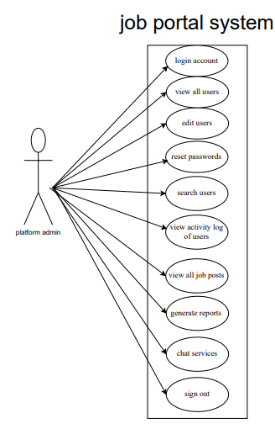

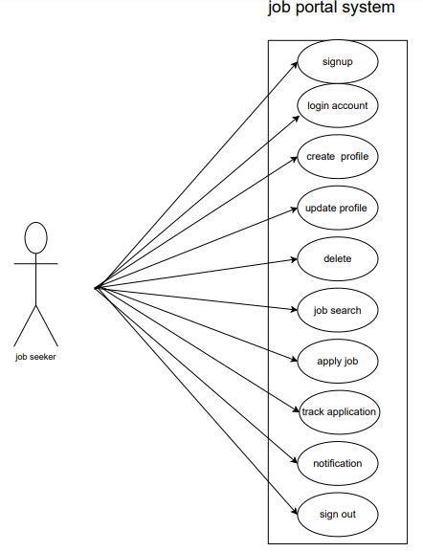
Jobseeker use case diagram

Employer use case diagram

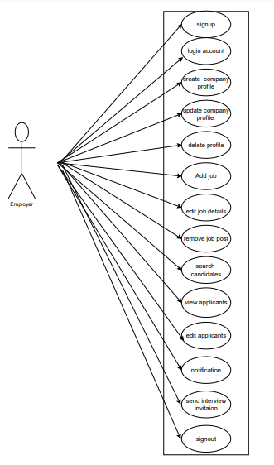
Job portal system

User stories

Employer user stories

AS | I NEED TO | SO THAT I CAN
Job Provider | Sign up using my email and secure password | Create an account to access the job portal service.
Job Provider | Receive a confirmation email after sign up | Know my account was successfully created.
Job Provider | Verify my phone number via an OTP | Know my account information is validated.
Job Provider | Login using my email and password | Access my account
Job Provider | Reset my password If I forget it | Regain access my account.
Job Provider | Receive a password reset link via email | Create a new password.
Job Provider | Create a company profile with my branding and values | Attract candidates who align with my organization.
Job Provider | Update basic company details | My profile reflects the latest information.
Job Provider | Delete my company profile | It is no longer visible on the platform if my organization no longer operates.
Job Provider | Create a new job listing | Attract suitable candidate.
Job Provider | Add job details such as title description, requirements, and location | Applicant understand the role and its expectations.
Job Provider | Specify the types of jobs (fulltime, part time, freelance) | Applicants know the nature of the position
Job Provider | Include salary or compensation information | Attract the right candidates.
Job Provider | Edit an existing job post | Update any outdated information.
Job Provider | Remove and deactivate a job post | It is no longer visible when the position is fulfilled.
Job Provider | Highlight my job post as featured | It appears prominently to job seekers.
Job Provider | Filter through job applications | Easily find suitable candidates.
Job Provider | Receive notifications when someone applies | Respond quickly.
Job Provider | View analytics for my job post | Measure the respond rate.
Job Provider | Manage applicants for my job postings | Find the best fit for the position.
Job Provider | View a list of applicants for each job postings | Review their profiles.
Job Provider | Filter applications by skills, experience and qualifications | Identify the most relevant candidates.
Job Provider | Search for candidates by location | Find individuals who are based near the job sites
Job Provider | Search candidates based on their availability such as immediate, within a month | Match their timeline with my hiring needs.
Job Provider | Track the status of each applicant such as shortlisted, interviewed, rejected | Manage the hiring process efficiently.
Job Provider | Download resume and portfolios | Review them offline.
Job Provider | Export application data to my HR system | Integrate it with my internal workflow.
Job Provider | I need to see a summary of my active job postings, candidate applications, and recent activity on the dashboard | Get a quick overview of my account.
Job Provider | Send messages to applicants directly through the platform | Communicate without sharing personal contact details.
Job Provider | Send interview invitations to shortlisted candidates | Schedule meeting easily.
Job Provider | Send rejection notification to candidates | They are informed about their application status.
Job Provider | Receive reminders about expiring job postings | Renew or update them.
Job Provider | Notified of platform updates or new features | Use them effectively.
Job Provider | Notified when a candidate updates their applications or profile | I have the latest information
Job Provider | Notified pending task such as reviewing applications, scheduling interviews | Ensure timely actions.
Job Provider | Alerted when my job post is expiring or inactive | Take necessary actions.
Job Provider | Sigh out from any device I am logged | Ensure that my account is secure.
Admin user stories
AS | I NEED TO | SO THAT I CAN
Platform Admin | Create a login by entering details | access to job portal system
Platform Admin | Verify phone number via OTP | Do Verification process
Platform Admin | View a list of all user accounts with filters | Find status of accounts like in active,active,suspended
Platform Admin | View detailed profiles of user | Verify their identity ,roles and activity logs
Platform Admin | Deactivate user accounts | Users violating policies are restricted from accessing the platform
Platform Admin | Permanently delete user accounts | Remove users who don't need the platform or are flagged as fake
Platform Admin | Edit user profiles | Correct errors or remove inappropriate content
Platform Admin | Reset user passwords upon request | Users who cannot access their accounts can login again
Platform Admin | Trigger password reset emails to users | Update their passwords securely
Platform Admin | Search for users by specific attributes like email,username,status | Quickly locate the account
Platform Admin | View the activity logos of a specific user like login history, job applications | Monitor suspicious or in appropriate behavior
Platform Admin | View all job post on the platform with filters | I can monitor the platform activity
Platform Admin | Review and approve job posts submitted by recruiters | Only real and valuable opportunities are posted on the platform.
Platform Admin | Reject job posts | Reject job post violated platform policies
Platform Admin | Delete job posts | Maintains platform integrity and quality
Platform Admin | Provide feedback when rejecting a job post | Recruiters can understand correct issues
Platform Admin | Review job posts reported by users | Investigate and take appropriate action
Platform Admin | Generate reports on job posts by category, industry or location | Share insights with the business team
Platform Admin | Generate reports on job posts like most popular industries, locations | Identify trends and improve the platform
Platform Admin | Sign out | Secure my account from others

Job seeker user stories
AS | I NEED TO | SO THAT I CAN
Job Seeker | Sign up using my email and secure password. | Enter the job portal system.
Job Seeker | A confirmation email received after sign up. | Account is created.
Job Seeker | Verify phone number through otp. | Account information is being validated.
Job Seeker | Login using email and password. | Access my account.
Job Seeker | Reset password if it is forgotten. | Regain my account.
Job Seeker | Reset new password with link. | Create a new password.
Job Seeker | Create a profile | Add essential needs to then profile.
Job Seeker | Update by information. | Details can be accurate.
Job Seeker | Delete my profile. | Remove all my information and data from the platform.
Job Seeker | Search jobs here. | Find many jobs on this platform.
Job Seeker | Mention about the convenient location. | Be able to sort out jobs regarding that.
Job Seeker | Set salary preferences. | See jobs related to the given information.
Job Seeker | Mention about the job type (part time/full time). | Get the preferences according to that.
Job Seeker | Mention about the correct areas of jobs. | Easily helps to find different categories of jobs.
Job Seeker | Get alert about my profile progress. | It helps to get alerts according to the mentioned filters about job title.
Job Seeker | Need to view and apply for the jobs. | Able to find jobs on this platform.
Job Seeker | Need to search for jobs according to my desires. | Quickly be able to find jobs according to my interest.
Job Seeker | Need to upload my resume/cover letter and other essential things. | That helps to submit my application in the correct way.
Job Seeker | Need to apply for jobs by filling out. | Apply for a job without any problem.
Job Seeker | Save my application and complete it later. | Which allows my time convenience to complete and submit later.
Job Seeker | Want to track the status of my application. | Which can know whether it is shortlisted, rejected or further steps.
Job Seeker | Need to receive notifications | Get to know about the details of the status of the jobs.
Job Seeker | Need to receive job alerts from new job listings. | Apply as soon as possible.
Job Seeker | Need to know whether the employer had received or seened the application. | Take further steps.
Job Seeker | Need to receive a notification whether invited for an interview or not. | I can confirm my availability and preparation.
Job Seeker | Able to receive alerts about the expiring dates. | Be able to submit the application as soon as possible.
Job Seeker | Be able to upload the certificates if they have been asked. | That the employers can view all the certificates and to know about qualifications.
Job Seeker | Sign out of my account. | Ensure my account is secure when I am done.

BPMN DIAGRAM

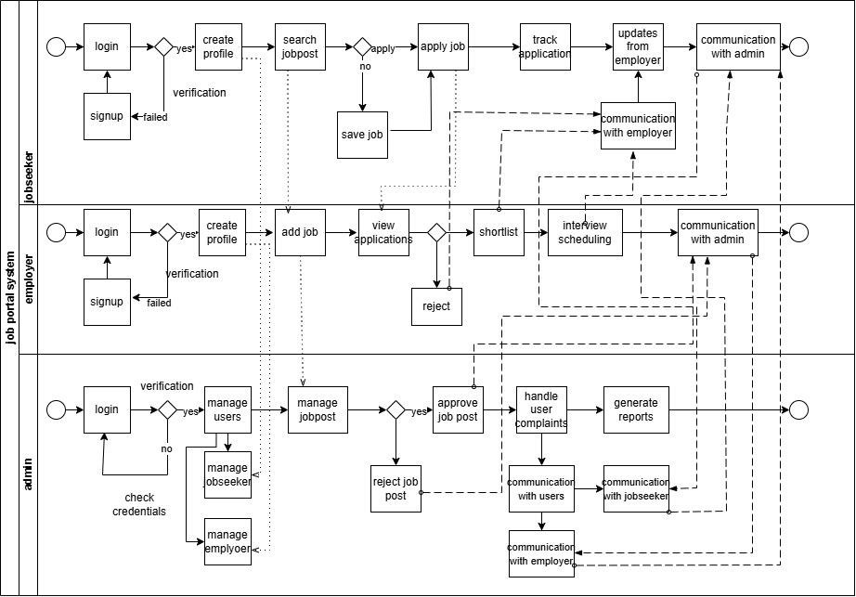

Non-Functional Requirements

The non-functional requirements of the job portal system define the quality attributes and operational standards that the system must meet to deliver a seamless and efficient user experience. These requirements are critical to ensuring the system's reliability, security, and overall usability, supporting its functional capabilities effectively.
Performance: The system must handle a high volume of concurrent users, including job seekers and employers, without significant degradation in speed or responsiveness. It should provide fast search results and efficient page loading, ensuring users can perform actions such as job searches or application submissions in real-time. The system should also scale to accommodate future growth in the number of users and data volume.
Reliability: The platform should maintain consistent uptime and be available to users 24/7, minimizing downtime and disruptions. Any system failures must be addressed promptly, with mechanisms for backup and recovery in place to prevent data loss. Regular maintenance and monitoring will ensure that the platform operates smoothly over time.
Security: To protect sensitive user information, such as personal details and resumes, the system must implement robust security measures. These include data encryption, secure user authentication, and protection against unauthorized access or cyber-attacks. Regular security audits and updates will ensure the system remains compliant with industry standards and resistant to emerging threats.
Usability: The platform should offer a simple, intuitive interface that is easy to navigate for all user roles, including job seekers, employers, and administrators. Features such as clear menus, helpful prompts, and responsive design for compatibility with mobile and desktop devices will enhance the user experience. Accessibility standards should also be met to ensure the platform is usable by individuals with disabilities.
By addressing these non-functional requirements, the job portal system will deliver a reliable, secure, and user-friendly platform that meets the expectations of its diverse user base. These attributes will complement the system’s functional capabilities, ensuring its long-term success and sustainability

Technical Requirements

HARDWARE REQUIREMENTS

Processor : Intel(R) Core(TM) i5-8th Generation

Installed RAM : 12.0 GB

SSD : 256 GB

System type : 64-bit operating system, x64-based processor

Operating system : windows 11

SOFTWARE REQUIREMENTS

Web development : HTML, CSS3, JAVA Script, Bootstrap

Back-end Development: ASP.Net, frameworks, visual studio IDE

Databases : MS SQL Server

Conclusion
The Software Requirements Specification (SRS) for the job portal system is a detailed guide for building and running the platform. It explains the system's goals, features, user roles, and technical requirements to ensure everyone involved understands how the system should work. By clearly describing both what the system will do and how it should perform, the SRS helps avoid confusion during development and ensures the final product meets user needs.
This document is essential for creating a reliable, secure, and easy-to-use platform that helps job seekers find jobs and employers find the right candidates. It sets the foundation for a system that simplifies the hiring process and can grow with future needs.

